Wireframe Design Milestone Project 1 Dale Harrison

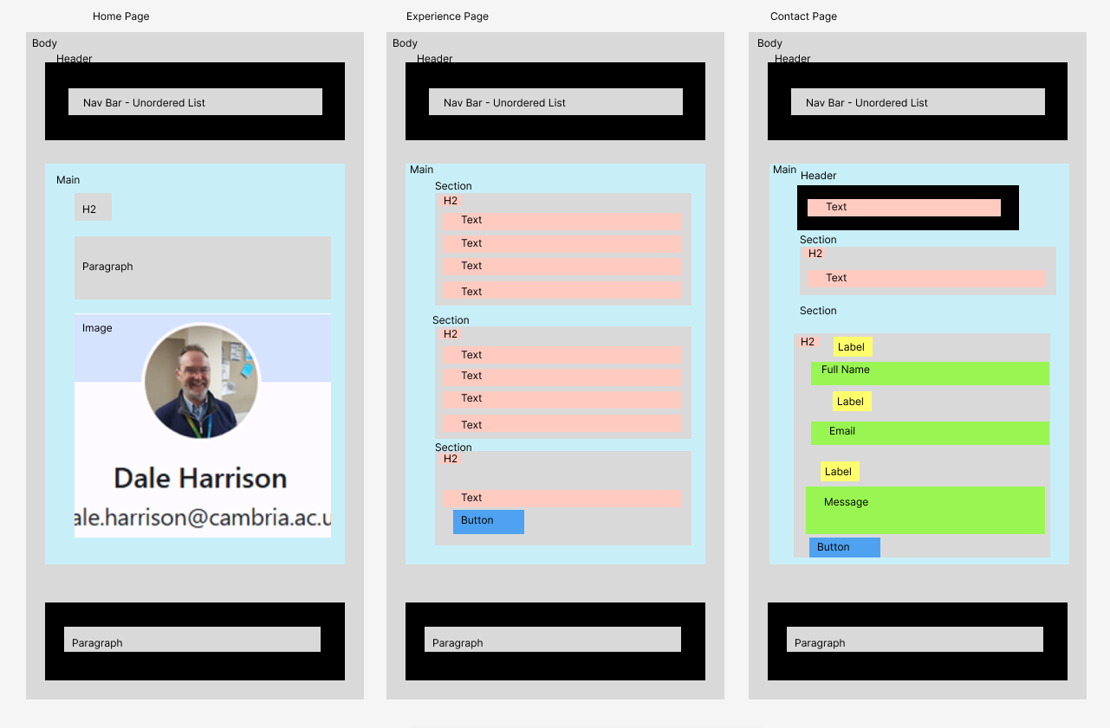

## 

## **Home Page**

**Header:**

* Navigation bar with links to "Home," "Experience," and "Contact"

**Main Content:**

* A large hero section with the title "Welcome to My Personal Resume Website"
* A short bio about myself, including your name, profession, and years of experience.
* An image of myself.

**Footer:**

* Copyright information for 2024.

## **Experience Page**

**Header:**

* Navigation bar with links to "Home," "Experience," and "Contact"

**Main Content:**

* A large title "My Experience & Qualifications"
* A section for "Work Experience" listing my previous positions in reverse chronological order. Each entry should include:
  + Job title and company name
  + Dates of employment
  + A brief description of my responsibilities and achievements.
* A section for "Education & Qualifications" listing your degrees and certifications, including:
  + Qualification name
  + Institution name
  + Year of award
* A section for "Download My CV" with a button allowing users to download your resume document.

## **Contact Page**

**Header:**

* Navigation bar with links to "Home," "Experience," and "Contact"

**Main Content:**

* A large title "Contact Me"
* A short introduction inviting users to reach out.
* A section for "Contact Information" displaying your:
  + Address
  + Phone number (with a link to open the phone dialer)
  + Email address (with a link to open a new email)
* A section for "Send a Message" with a contact form allowing users to send me a message. The form should include fields for:
  + Name
  + Email
  + Message
* A submit button for the contact form.

**Footer:**

* Copyright information for 2024.